**78897699**

Agreement url:   
  
  
  
https://www.e-jkfn.org/main.html

Year

Month

Volume

Issue

Click here to get Current Issue

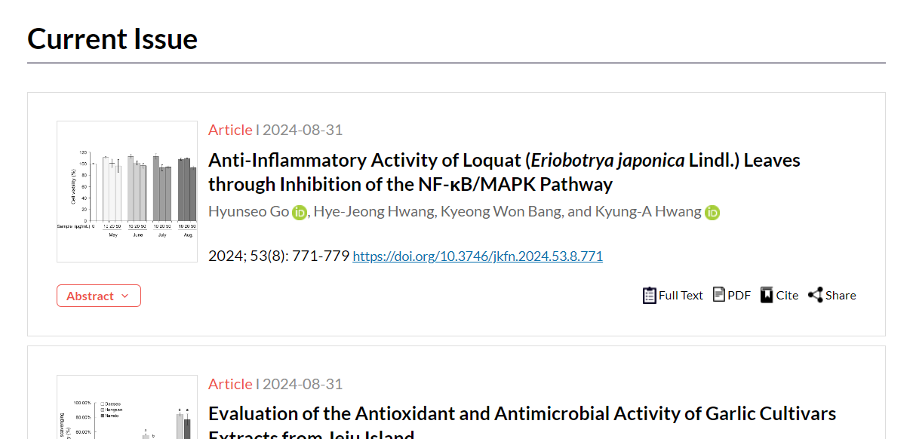

Download the pdf

Article title

Page range

DOI